Perseus and Medusa

Polydectes (pol-ee-DECK-teez), evil king of the island of Seriphos (SERR-i-fos), fell madly in love with a beautiful woman named Danae (DAN-eye). He wanted to marry Danae, but wanted nothing to do with her adult son, Perseus. Hoping to get rid of Perseus, Polydectes ruthlessly tricked the young man into brashly undertaking a deadly mission - to bring him the head of a dreaded monster called Medusa.

Medusa was one of three fearsome Gorgon sisters who lived far away in a secret hiding place. The sisters had brass claws, golden wings, boars' tusks, and masses of hissing snakes for hair. Anyone who looked into their frightful faces instantly turned into stone.

Fortunately, the gods Athena and Hermes, as well as three nymphs, offered to help Perseus. Athena gave him a shiny bronze shield and Hermes gave him a sword that could not be bent by the Gorgons' scales. The nymphs gave Perseus winged shoes so that he could fly, a cap that made him invisible, and a pouch in which to carry the Gorgon's head.
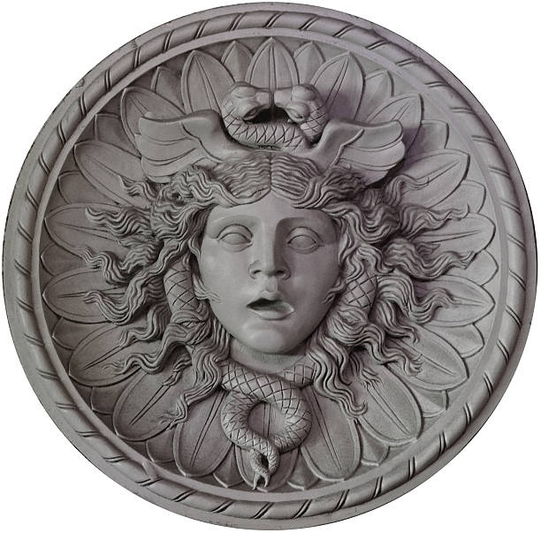
Perseus flew first to the home of the aged ones. These three women, who were sisters to the Gorgons, were born with grey hair and shared a single eye and tooth between them. Wearing his cap of invisibility, Perseus snatched the eye as one sister passed it to another. Threatening to keep the eye, Perseus coerced them into revealing the Gorgon's secret hiding place.

Perseus arrived at the cave of the Gorgons, where, by good fortune, they were all asleep. In order to see Medusa without turning to stone, Perseus located her grotesque face in a reflection on his shiny shield. He swiftly cut off her head, dropped it into his bag, and fled from Medusa's angry sisters. When Perseus returned to Seriphos, the evil Polydectes laughed at him and asked what was in his sack. Perseus pulled out the horrifying head of Medusa and turned Polydectes to stone.

Medusa's severed head retained its power to turn people into stone, so Perseus carried it on many adventures, using it to defeat his enemies. Eventually, in gratitude for her protection, Perseus gave Medusa's head to Athena, who placed it on her breastplate to ward off evil.

